07th October 2019

**YOKOHAMA wins Tyre Manufacturer of the Year 2019 Award by NTDA**

Yokohama has won its first ever NTDA Tyre Manufacturer of the Year award at the Tyre Industry Awards ceremony in Birmingham, UK. The award is presented to the company that, in the judges’ opinion, demonstrates that it is the best all-round ambassador for competitive manufacturing, service provision and a role model for its peers in the industry.

The awards ceremony followed a day conference focusing on investing in the tyre industry’s personnel, technology and the trends associated with the next generation. Around 600 members of the UK tyre industry gathered at the ICC in Birmingham for the 90th annual NTDA dinner and Tyre Industry Awards.

In the picture, representatives of YOKOHAMA UK, Yokohama High Performance Tyres Ltd and YOKOHAMA Europe Executive Vice President pose proudly with the award.

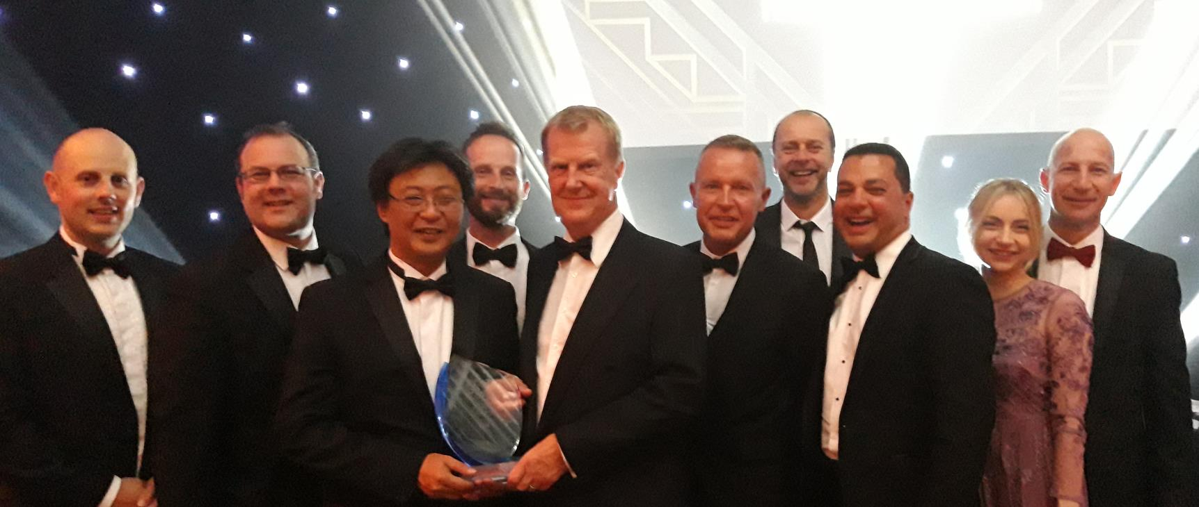

*NTDA 2019 Tyre Manufacturer of the Year Winner YHPT Ltd from L to R Michael Harrington James Brown Eisuke Imai Joe Tomlin David Seward Tony Valentine Nick Greenfield Danny Rughoobeer Lucy Burham Graham Fieldhouse*

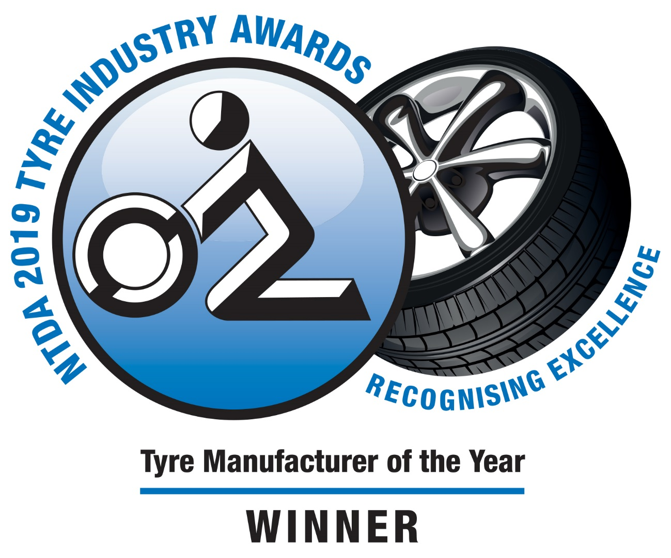

*TIA Logo Tyre Manufacture Winner Outline*